The following steps will guide you through the Pluralsight login and ***ensure Cloud sandbox environments accessibility*** on the day of the session**. In case you face issues, pls contact Sonia Thomas who will help you in sorting it out.**

Pls **complete these actions in your *Personal Laptop* before 15/11/2022.**

1. Since the **SG network** firewall **restricts** **access** to the Cloud sandbox environment. **You are required to use your personal laptop and wifi (unrestricted connectivity)** for the following actions.
2. By this time, you should have received email from PluralSight confirming the creation of your login. Use your Chrome or Edge browser and navigate to <https://www.pluralsight.com> . Click the option **“Sign in to SKILLS”** from the top right corner of the page

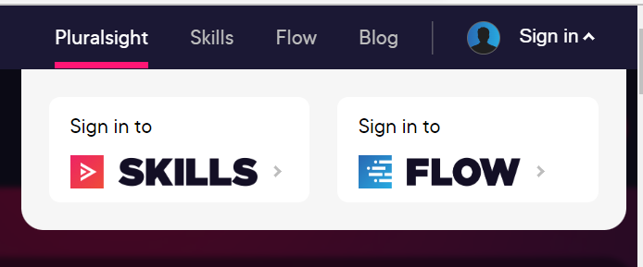

1. In the login page, provide your Email and Password to login to Pluralsight.

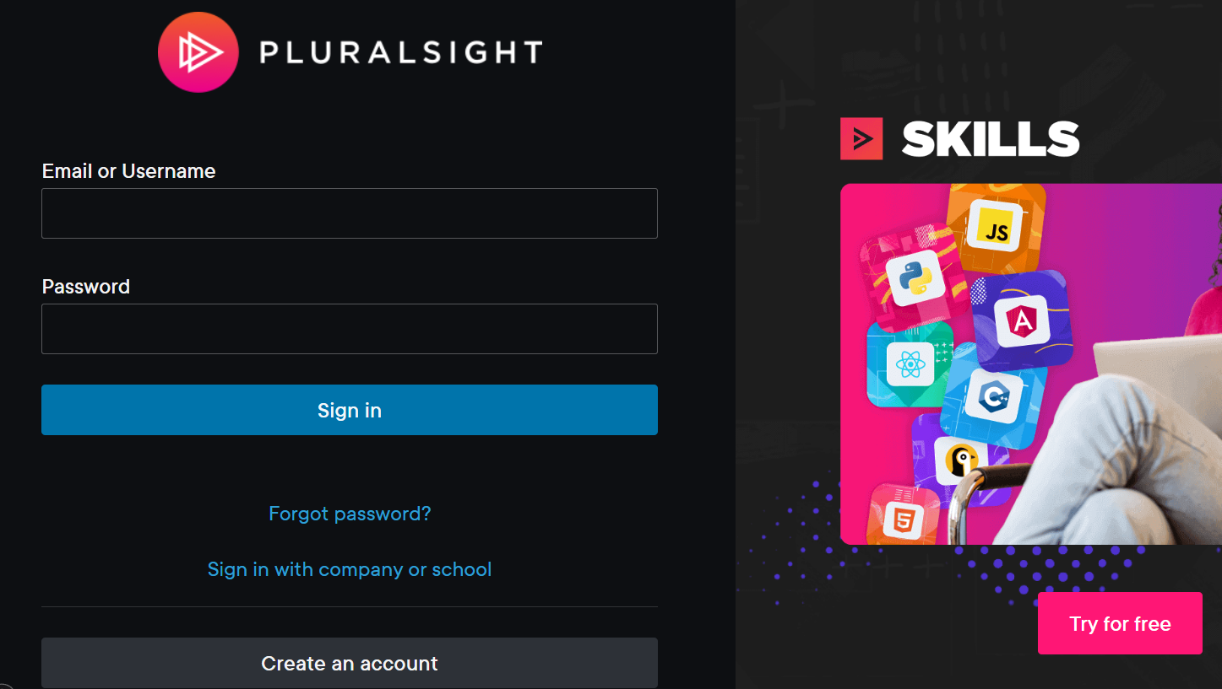

1. In the following page, use the Search feature on the top and type “**Create and Manage Resource Groups in Microsoft Azure**” in the search text box. Hit enter to see results in the following page.



1. You will see search results in the page with a list of Labs and Courses . Click on the first link that has “**Lab**”

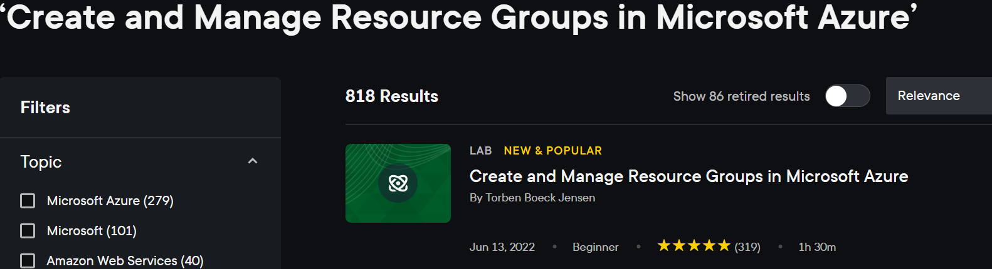

In the following page, click on “**Start Lab**”

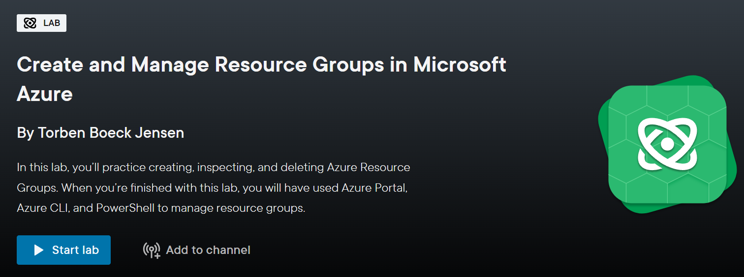

1. Your Sandbox Cloud environment should begin loading

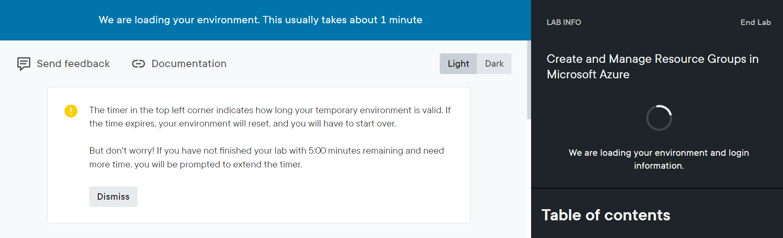

**Wait for few minutes**.

You should see the page completely loaded and a temporary Email & Password that Pluralsight assigns. You will use these as credentials to login to Azure Portal.

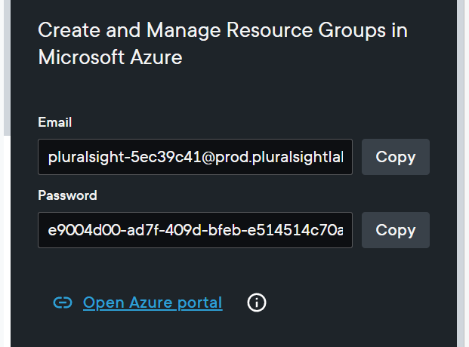

1. Click on the “**Open Azure portal**” link.
2. In the following page, you will be prompted for Email and Password where you can use the **Copy** feature to provide the credentials to Sign In.

|  |  |
| --- | --- |
|  |  |
|  |  |
|  |  |

1. Once you are logged in to the Azure Portal, you will see the following page.

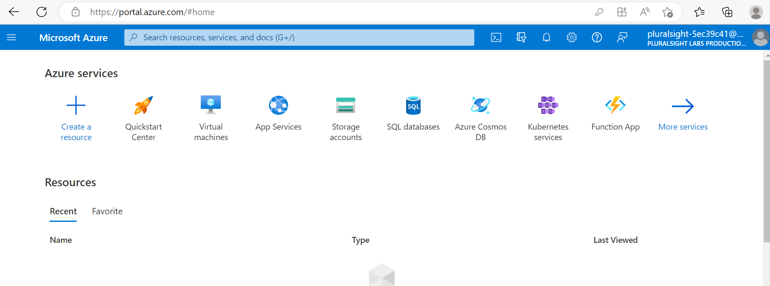

**Congratulations, you are all set for the Cloud Session on 21/11**

Feel free to browse and play around the Azure Portal.

In case you get stuck or have questions on the actions, pls reach me or Sonia Thomas